The text book chapter back exercises are also good for practicing.
For the below path finding problem , if the goal is for the robot to search for path to reach the goal(location of lock), answer the below questions:
- Define the PEAS description
- For given problem , for each of the type of dimensions of the task environment , suggest your own case study in no more 30 words a scenario, suitable to define such types of the task environment
- Which agent architecture is best suitable to each of your above scenarios that you have designed in previous question? Justify in short answer.
- Assuming deterministic, static, fully observable , single agent task environment:
- Suggest atleast 2 suitable path cost g(n) to quantify the effort of search in reaching the current node 'n' from the start node.
- Suggest atleast 2 suitable heuristic cost h(n) to quantify the effort required by agent to reach goal node from the current node 'n'.
5. For each of the below algorithm , perform the following
- Construct a search tree for up to 3 level (root includes level 0 )
- Select one among the path cost design to apply for respective algorithms below. Justify your choice
- Select one of among the heuristic cost design to apply for respective algorithms below. Justify your choice by the property of optimality , consistency
- Use the tabulated trace recommended by the faculty in class to show the step by step working of algorithm till first 4 iterations or the 3 levels of search tree generation whichever is achieved the latest in respective algorithms.
- Breadth first search
- Depth First Search
- Uninform Cost search
- Iterative Deepening Depth First search
- Greedy Best First Search
- A* search
- Iterative Deepening A*
- Recursive Best First Search
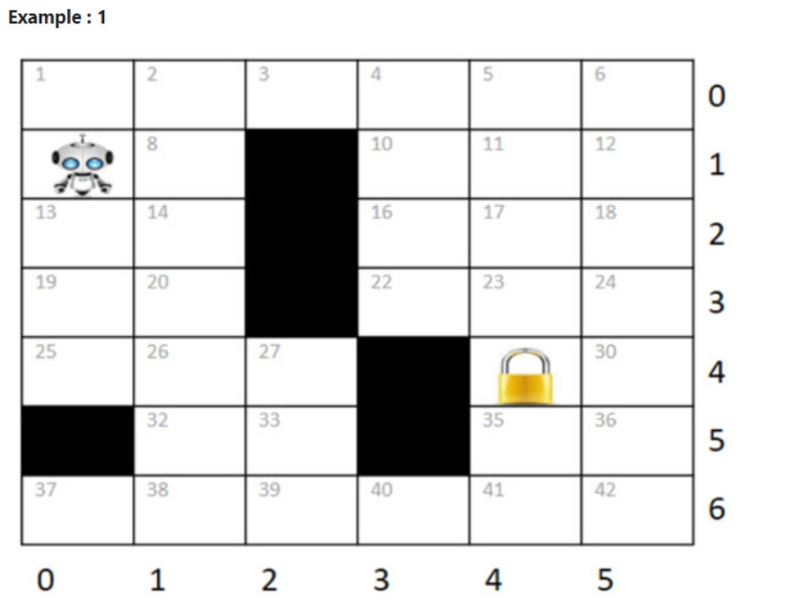
Example : 2
Consider the below initial and goal state of the problem and answer the following questions. In a color palette board arrangement problem, there are 8 different colors, a water bowl (W), a paint brush (PB), and two empty cells (E) provided. The neighboring elements of an empty tile on the color palette board, such as colored tiles, the water bowl, and the paintbrush, can swap their positions with the empty tile. An agent should find a path ie., series to swapping from the Initial state to achieve the Goal state.
Note: To understand the definition of neighbors, in the Goal state below colored tile Light Blue (8), Dark Orange (1) and water bowl (W), Paint brush (PB) are neighbors to one of the empty tile. same approach applicable for another empty cell
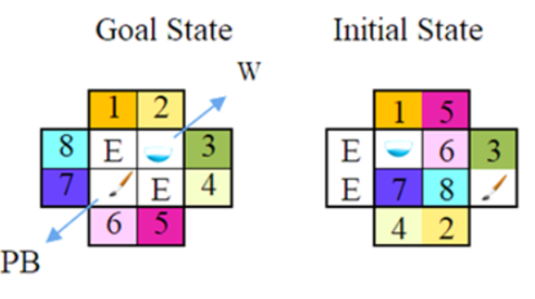
Construct a search tree for up to 2 level (root includes level 0 )
Each transition will add a uniform path cost = 10 if the empty tiles are neither in the same row nor in the same column w.r.t resultant state. If they are in same column or in the same row the path cost must be cost = 5. When swapping the water bowl with an empty tile, add an additional cost of 3 for that resultant state.
Consider the heuristic design as : H2: Sum of Manhattan distances of all the misplaced tiles w.r.t to the goal state

